Filter a SQL Query – Investigating Login Attempts

Scenario
I worked on a database querying project to investigate login attempts following a security incident. The objective was to filter login data by date, time, and event ID to identify unusual activity and generate actionable insights.

Tasks & Solutions
Task 1: Retrieve login attempts after a certain date
- Action A: Determine how many login attempts were made after 2022-05-09.
SELECT *
FROM log_in_attempts
WHERE login_date > '2022-05-09';
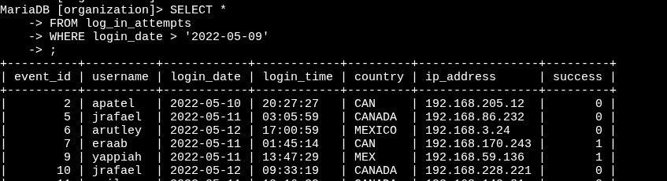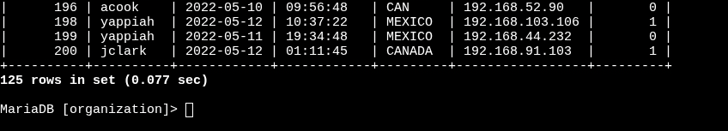
- Result: 125 login attempts

- Action B: Determine how many login attempts were made on or after 2022-05-09.

SELECT *
FROM log_in_attempts
WHERE login_date >= '2022-05-09';
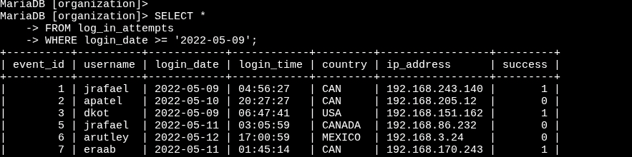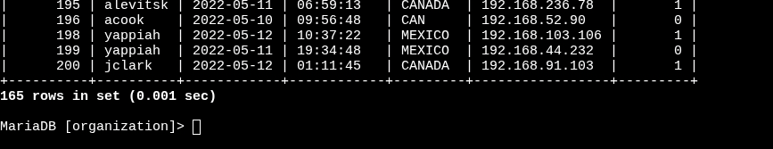
- Result: 165 login attempts

Task 2: Retrieve logins in a date range
- Action: Determine how many login attempts were made between 2022-05-09 and 2022-05-11.
SELECT *
FROM log_in_attempts
WHERE login_date BETWEEN '2022-05-09' AND '2022-05-11';
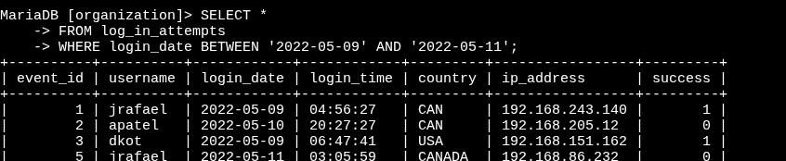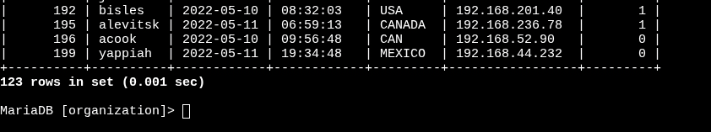
- Result: 123 login attempts
Task 3: Investigate logins at certain times
- Action A: Retrieve all login attempts made before 07:00:00 to check for activity outside work hours.
SELECT *
FROM log_in_attempts
WHERE login_time < '07:00:00';
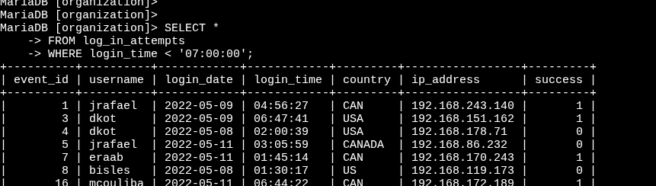
Result: The username of the fifth record returned = eraab
Action B: Narrow the results to logins made between 06:00:00 and 07:00:00.
SELECT *
FROM log_in_attempts
WHERE login_time BETWEEN '06:00:00' AND '07:00:00';
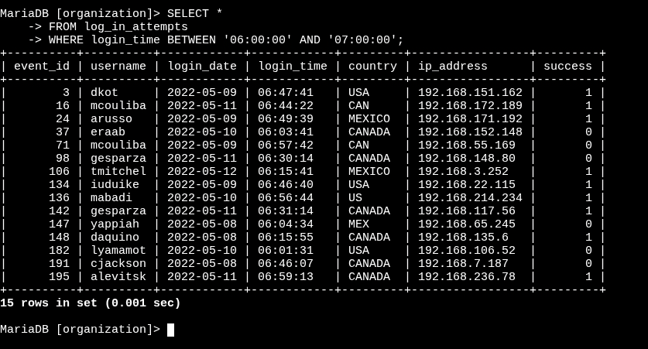
Result: The earliest login attempt occurred at 06:01:31.
Task 4: Investigate logins by event ID
- Action A: Return login attempts with event_id >= 100, selecting only the event_id, username, and login_date columns.
SELECT event_id, username, login_date
FROM log_in_attempts
WHERE event_id >= 100;
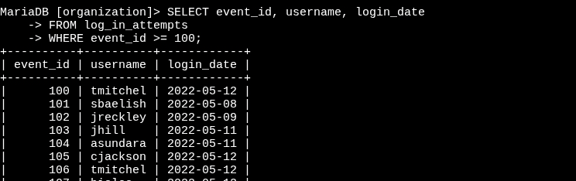
- Result: The login date of the third record = 2022-05-09
- Action B: Narrow results to only those with event_id between 100 and 150.
SELECT event_id, username, login_date
FROM log_in_attempts
WHERE event_id BETWEEN 100 AND 150;
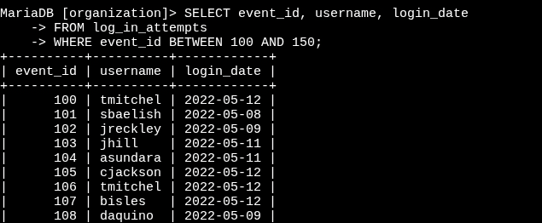
- Result: The username of the seventh record returned = tmitchel.

Key SQL Skills Demonstrated
- Using comparison operators (>, >=, <) to filter results.
- Applying BETWEEN with AND for date and time ranges.
- Filtering results by numeric values (event_id).
- Selecting only required columns for efficient queries.

Outcome
This project highlighted my ability to filter SQL queries by dates, times, and numeric ranges to investigate system activity. These skills are critical for tasks such as security monitoring, incident analysis, and compliance reporting.

